Russian Academy of Sciences
Scientific Council on Mathematical Biology and Bioinformatics
Institute of Mathematical Problems of Biology

The 1st International Conference on Mathematical Biology and Bioinformatics ICMBB06

Pushchino Moscow region

October 9-15, 2006
THIRD BULLETIN
The 1st International Conference on Mathematical Biology and Bioinformatics - ICMBB06 - brings together scientists and students from Russia and all over the world to discuss recent advances in mathematical and computational biology, bioinformatics and applications. The conference will be held at Pushchino Research Center (Pushchino Moscow region), October 9-15, 2006. ICMBB06 is the first, as planning, bi-annual conference of the Scientific Council on Mathematical Biology and Bioinformatics of the Russian Academy of Sciences.
The conference has following objectives:
(1) to communicate the best of recent advances in mathematical modeling approaches in the life sciences and to identify key targets of future work and

(2) to provide a platform for young researchers.
The preliminary program of the Conference includes the following main topics:
- Theoretical molecular biology and genetics
- Mathematical Physiology
- Cellular biophysics
- Regulatory and nonlinear systems
- Evolution and ecology
- Epidemiology
- Neural systems and the brain
- Immune system
- Biomedical applications
- Biotechnology
- Innovative mathematical and computer methods
- Data analysis and model validation
- Inter-disciplinary education
Applications are invited for contributed and poster presentations. In addition, researchers interested in organizing mini-symposia are invited to submit their proposals. The conference is designed for researchers who are active in or interested in this fast growing field where experimental biology and medicine, biochemistry, computational biology, mathematics, computer science, physics and various fields of technology merge.
Plenary lectures and invited talks (30 min.) are scheduled during the morning sessions. Two parallel sessions (except Wednesday) with short talks (15 min.) will be held in the afternoons. Contributions to be given as talks will be selected by the Organizing Committee on the recommendation of the International Program Committee.
The plenary lecture and invited talk speakers will be specified in the next bulletin.

About 200 scientists are expected to attend the ICMBB06 Conference. The Conference will start on Monday, October 9, at 10 a.m. and end on Friday, October 13. The arrivals will be on Sunday afternoon, October 8 and departures on Sunday, October 15.
The working languages of the Conference are English and Russian.
Conference chairman: V.D. Lakhno (Dr.Sci., IMPB RAS)
Honorary chairman: A.M.Molchanov (Dr.Sci., IMPB RAS)

International Program Committee

Aleksandrov A.A., Dr.Sci.
Arsen'ev A.S., Dr.Sci.
Archakov A.I., Dr.Sci., Akad. RAMS,
Berdyshev V.I., Dr.Sci., Corr.Mem. RAS
Vasin A.A., Dr.Sci.
Degermendj`i A.G., Dr.Sci., Corr.Mem. RAS
Evtushenko Yu.G., Dr.Sci., Corr.Mem. RAS
J`ij`chenko A.B., Dr.Sci., Corr.Mem. RAS
Il'in V.A., Dr.Sci.
Kozlov N.N., Dr.Sci.
Kolchanov N.A., Dr.Sci., Corr.Mem. RAS
Korotkov E.V., Dr.Sci.
Levin V.K., Dr.Sci., Akad. RAS,
Markhasin V.S., Dr.Sci., Corr.Mem. RAS
Markov A.V., Dr.Sci.
Matveev S.V., Dr.Sci., Corr.Mem. RAS
Mironov A.A., Dr.Sci.
Nazipova N.N., Cand.Sci.
Riznichenko G.Yu., Dr.Sci.
Romanyukha A.A., Dr.Sci.
Rubin A.B., Dr.Sci., prof., Corr.Mem. RAS
Rudakov K.V., Dr.Sci., Corr.Mem. RAS
Samsonova M.G., Cand.Sci.
Tumanjan V.G., Dr.Sci.
Ustinin M.N., Dr.Sci.
Fedotov A.M., Dr.Sci., Corr.Mem. RAS
Frisman E.J., Dr.Sci.
Chetverushkin B.N., Dr.Sci., Corr.Mem. RAS
Shabanov B.M., Cand.Sci.
Shaytan K.V., Dr.Sci.
Shokin Yu.I., Dr.Sci., Akad. RAS

Fees
The conference fee covers conference halls lending, conference materials, proceedings, coffee breaks and social program. The full conference fee for researchers amounts to 250 € (3000 rubles for Post-Soviet scientists), for students 125 € (1500 rubles for Post-Soviet students and graduate students), for participants representing Russian commercial firms the fee is 4500 rubles.
Hotel accommodation and feed imply the payment of extra costs.
The conference fee for accompanying persons is 150 € per person. This includes a social program.

Deadlines
The deadline for abstract (two A4 page format) submission for the book of abstracts is June 01,
2006. Please, find the sample file for the abstract at the conference site http://www.impb.ru/~ icmbb06
The deadline for registration is June 01, 2006 (completed registration form is posted by e-mail both with prepared abstract.
The deadline for the contribution submission to the conference proceedings (full articles) is September 01, 2006.
For all communication and information please use the Conference
E-mail: ICMBB06@conference.ras.ru
icmbb06@impb.ru.
Ekaterina Ukhanova
Tel: +7(495) 938-18-61, 938-18-51, 938-05-21
Fax: +7(495) 938-10-11
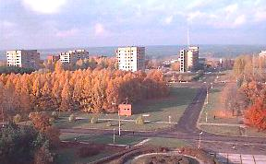
Social Programme
The social program will include the Welcome Party on Monday evening, October 9, a trip on Wednesday afternoon, October 11 and a banquet on Friday, October 13

About Pushchino:

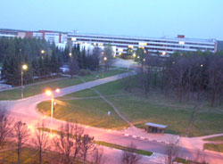
The city of Pushchino is located 120 kilometers to the South of Moscow on the bank of the Oka river on the highest spot of Moscow region. Directly across the river from Pushchino is located Prioksko-Terrasny Nature Reserve.
The city occupying the territory of 1783,7 ha fits naturally into the surrounding landscape harmonizing perfectly with its beauty. In the design and construction of the city special attention was given to the relief of the terrain so that maximum all-round view of the sky, the river and the woods be open.
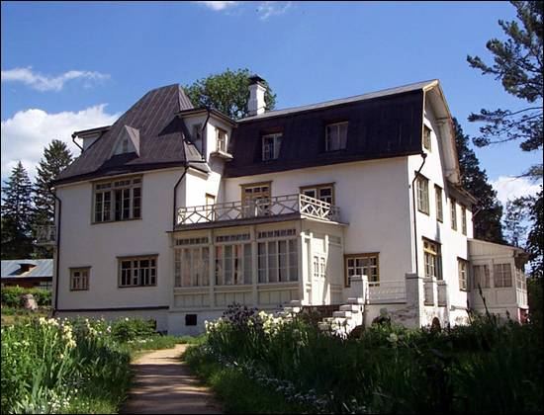
Due to the lack of any industrial enterprises or unhealthy works, the ecological situation in the city is kind.
The uniqueness of the city is also in that the picturesque surroundings and the elements of the city architecture complement each other nicely.
The sights of the city are the Pushchino estate, which is a historical monument of the XVIII century, Spas-Teshilov settlement, 5 State unique landscapes, which are nature reserves of regional importance.
Near Pushchino there is Polenov’s museum-estate, Chekhov’s museum-estate (Melikhovo), the city of Serpukhov with ancient churches, Vysotsky Monastery and Museum of Art and History.

Additional Information
A basic description of the venue of the conference can be found at the web-site (will be accessible since March 01, 2006):
http://www.impb.ru/~ icmbb06

The Proceedings will be published soon after the Conference.

For all communication and information please use the Conference
E-mail: ICMBB06@conference.ras.ru
icmbb06@impb.ru.
Ekaterina Ukhanova
Tel: +7(495) 938-18-61, 938-18-51, 938-05-21
Fax: +7(495) 938-10-11
Institute of Mathematical Problems of Biology Phone: (+7 4967) 732408
Russian Academy of Sciences Fax: (+7 4967) 330570
From Moscow and Moscow reg.
4 Institutskaya Str. Pushchino Phone: (27) 732408
Moscow region 142290, Russia Fax: (27) 330570
Contact person Sergey A. Makhortykh

