
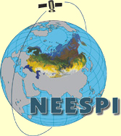

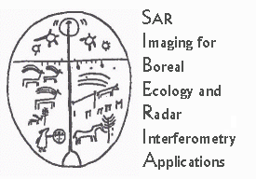
Sib - E S S - C
SIBERIA-II Earth System Science Cluster




Environmental change in Siberia – Insights from Earth Observation and modelling

IMPORTANT DATES

21 July Deadline for submission of abstracts, and requests for travel assistance
25 July Decision on travel assistance
25 August Final Programme published, authors notified
18-20 September Symposium at University of Leicester, UK

