
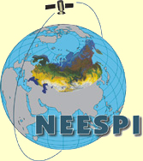

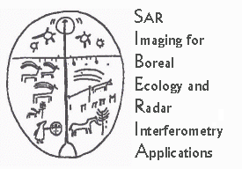


Sib - E S S - C
SIBERIA-II Earth System Science Cluster

SYMPOSIUM

Environmental change in Siberia –
Insights from Earth Observation and modelling
First announcement and call for papers
18-20 September 2006
University of Leicester, UK

Siberia is witnessing environmental change of dramatic magnitude. Human induced land cover change occurs at high speed. Tundra ecosystems are under threat from increasing fire outbreaks, with longer term impacts on reindeer populations. Permafrost melt due to global warming is expected to release large amounts of methane and to increase soil drainage and consequently river runoff into the Arctic ocean. The taiga forest is affected by recent large fire outbreaks, which could be the first sign of an accelerating fire regime in a warmer world. The resulting spatial heterogeneity feeds back on the climate system through a changed radiation and water balance.
Advances in the quality and accessibility of Earth Observation data products and increasing evidence for the importance of the land surface in the climate system point to the need for an Earth system approach to understand these change processes and their consequences.
An anticipated outcome of the symposium is a concept for the integration of knowledge about spatial patterns derived from Earth Observation and process knowledge formalised in ecological / biophysical models in an Earth System Science Cluster (Sib-ESS-C) to advance our understanding of environmental change in the Siberian region.
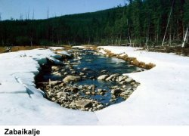
Picture courtesy of IIASA/RAS
The symposium aims to explore how human and biophysical processes interact under conditions of rapid environmental change.
The participants will have the opportunity to discuss novel approaches to spatial and temporal data integration, including human activities, climate, vegetation and the atmosphere with the aim to better understand, quantify and predict environmental change in the region.

SIB-ESS-C Overall Objectives
- Develop a spatial data infrastructure to facilitate Earth system science studies in central Siberia (specifically the Yennissey watershed)
- Set up a web interface to provide access to data products created during the SIBERIA-II project
- Continue remote sensing data acquisition and product generation to build up time series
- Provide online geo-visualization tools for integrated data analysis

SIB-ESS-C Data and Products
In the initial phase of the SIB-ESS-C project, data sets and value-added products created within the SIBERIA-II project will form the basic set of products to be disseminated. A major goal of SIB-ESS-C is to continue product generation in order to build up time series for environmental monitoring and as input parameters for earth science models. As research is advancing and new algorithms and data products are being developed additional data sets of the region shall be included. In order to provide a comprehensive spectrum of data sets relevant for earth systems research collaboration with other data providers and research organisations to share data sets is highly desired.
The SIB-ESS-C Database will consist of:
- SIBERIA-II metadata
- SIBERIA-II "raw" satellite data
- SIBERIA-II Earth Observation products
- IIASA's Landscape GIS for the SIBERIA-II region including forest inventory information for approx. 70 test regions,

SIB-ESS-C Users and Applications
Intended applications and users (others are welcome too):
- Earth System Science Partnership projects,
- Ecosystem response due to global change
- support to convention implementation (e.g. Kyoto Protocol, UN Convention on Biodiversity),
- socio-economical aspects / sustainable development / IHDP Programme.
- Forest Management / monitoring
- Detection of disturbances

SIB-ESS-C Services
- Catalogue Service: providing meta data on products and procedures (search / find data)
- Coverage Service: providing direct access to datasets available from SIB-ESS-C (access and download data)
- Map Service: visualization of geographic datasets available from SIB-ESS-C
- Analysis Service: advanced visualization tools for integrated data analysis (integration of multiple data sets, spatially and temporally)
- Customization Service: based on previous data analysis users should be enabled to retrieve customized data products according to their requirements
- Processing Service: continuous EO-product generation

Contacts:
Dr Heiko Balzter, Centre for Ecology and Hydrology, Monks Wood, UK, email hbal@ceh.ac.uk
After 1 September: University of Leicester, UK, email heiko.balzter@le.ac.uk
Prof. Christiane Schmullius, FSU Jena, Germany, email: c.schmullius@uni-jena.de

